Instructions for Making a PowerPoint Presentation Accessible

1. PowerPoint Presentation Design
a. Click the Design tab
b. Click the desired template for the PowerPoint Presentation.
1. Select a template with:
a. Readable Font Style—Arial or Verdana
b. Readable Font size—12 or larger
c. Contrast—Black text on White background
d. Color
1. Not used alone for emphasis
a. Color
b. Bold
2. Limited use of color
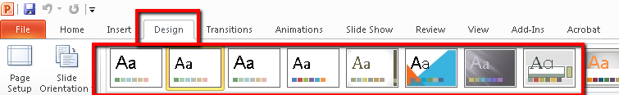

2. Slide Theme
a. Click “New Slide” to add slides to the presentation.
b. Do NOT use the Blank template
c. Do NOT add text boxes to a slide. (They cannot be read by a screen reader.)
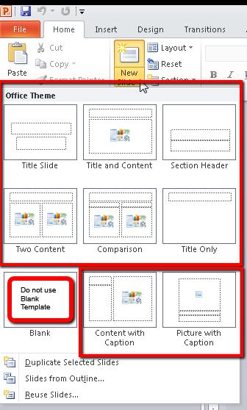
3. Slide Layout
a. Click Layout to change the Layout of a slide
b. Do NOT use the Blank template
c. Do NOT add text boxes to a slide. (They cannot be read by a screen reader.)
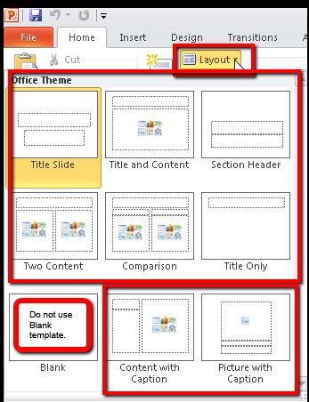

4. Images, Charts, and Graphs in PowerPoint Presentations

Adding Alt Text to Image, Chart or Graph | Adding descriptive text on a slide
1a. Images, charts, graphs  a. Alt Text  i. Right click on image  ii. Select Format Image  iii. Select Alt Text  iv. Enter Alt Text in the Description field if | 1b. Images, charts, graphs  b. Descriptive text  i. Enter before or after  ii. Chart, graph, or image  iii. Enter the Descriptive text

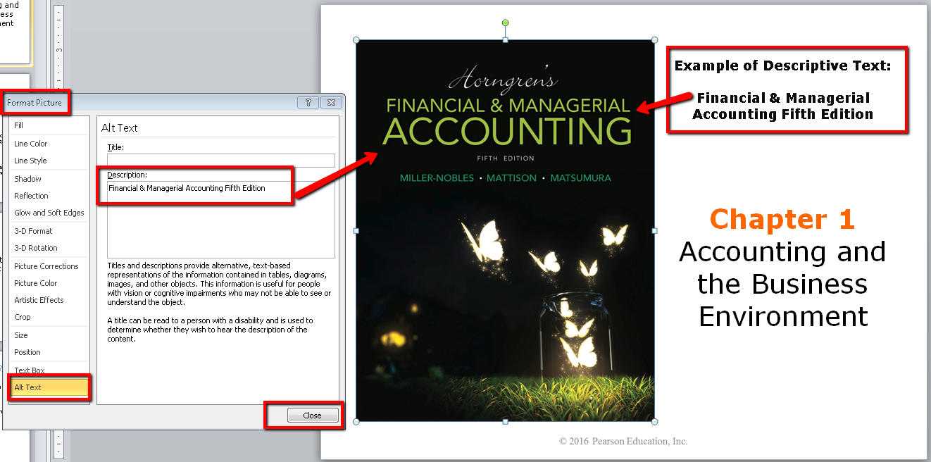
5. In order to check how a colorblind person sees your presentation:
a. Click the View tab
b. Then Grayscale
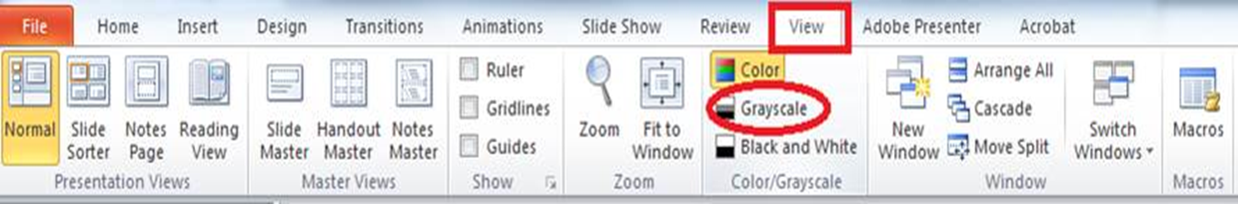

6. To run the accessibility checker:
- Click on file tab, and then info
- Click the check for issues button
- Then click on check accessibility
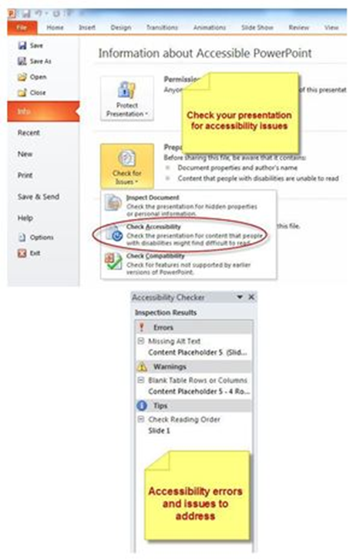
7. Table tools design tab:
- Be sure there is enough contrast between the text and background colors of each cell.
- Choose a table style that provides grid lines to separate the data cells

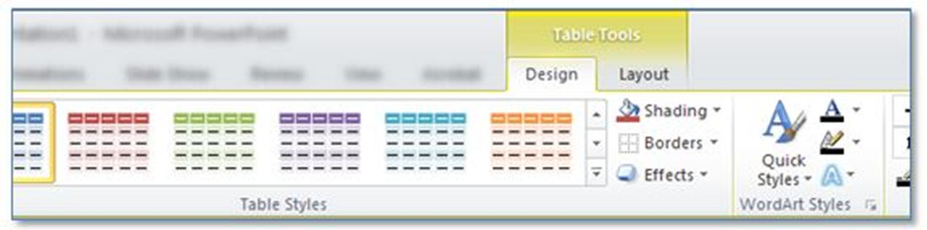

8. To check the reading order:
- Go to the Home Tab
- In the Drawing group of commands, select Arrange
- Then Selection Pane.