Instructions for Making a Word Document Accessible

***Only 1 Heading 1 per document or page****
Heading of Document  a. Select text  b. Click on Heading 1  1a & 1b  c. Right click Heading 1  d. Click “Modify”  1c & 1d  e. In Formatting area  1. Select Black  1e & 1-5  2. Select Bold  3. Select Font size 16  4. Select Arial  5. Select Centered  1f  f. Click OK  2.  2. Subheadings  a. Select Heading 2 or 3  b. Follow instructions in Item 1, if Heading/s need to be formatted  3. Color not used alone for emphasis  3.  a. Bold  b. Color  4. Content  4.  a. Font Arial/Verdana  b. Font size 12  5. Contrast  5  a. Black text on White background  6. Images, charts, graphs  a. Descriptive text  6a  Add before or after Image, chart, or graph.  b. Alt text  1. Right click on image  2. Select Format Picture  3. Select Alt Text  4. Enter text in  Description box “Alt text needed, please, contact the instructor for this information.”  6b  5. Click Close  Contact Accessibility Lead if you have any questions. | 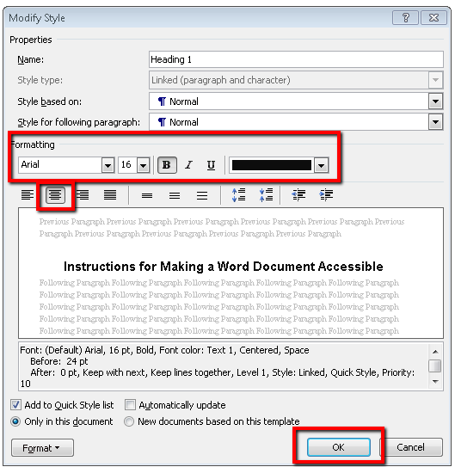  Limitations and Delimitations of the Study  The limitations of the study are not under the control of the researcher. Limitations are factors that may have an effect on the interpretation of the findings or on the generalizability of the results.  Limitations may arise from the methodology, data, or method of analysis. For example, the findings of a case study cannot be generalized to an entire population. Data derived from a study of drug use in an attendance area of a large, urban school district may not be representative of all school age children in the United States or in other school districts in the same state, or even in other schools within the same district.  A finding that school size correlates negatively with student behavior problems may not justify the inference that small schools cause student behavior problems. You need to state the limitations of your study to avoid misinterpretation of the findings.  Delimitations  Delimitations are self-imposed boundaries set by the researcher on the purpose and scope of the study. Studies have many variables that could be affected by circumstances of time, location, populations, or environment (including both physical and social conditions).  Boundaries and qualifications are inherent in every study, which must be noted in this section of the dissertation.  See the example of delimitations from Craig Coleman’s (2003) dissertation on p. 134 in Lunenburg and Irby (2008) Writing a Successful Thesis or Dissertation: Tips and Strategies for Students in the Social and Behavioral Sciences course textbook.  Descriptive text needed, please, contact the instructor for this information.”  