(Not) Plain Word
October 2016

To Use Headings

- With your cursor in the area of the Word doc you want to change to a heading

- Select the “Home” tab.

- Styles should be located in the middle of the “ribbon”

- Select the style you want to use, Heading 1, 2, 3, 4, etc. Recommend only using 4 levels of headings.

- Once the heading selection is made, you can check how it affects the navigation by turning on the Navigation Pane under the View Tab. Click to make the check box active and it should now display the Navigation Pane in the left side of the screen.

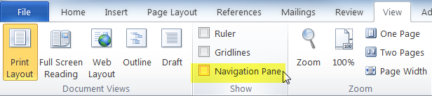

To Use Alt Text
- Once an image is inserted into your Word document, right click on it to access the “Format Picture” option.

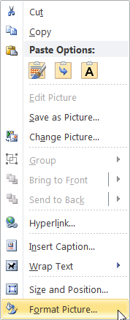

- This will activate the Format Picture dialog box where “Alt Text” is the last option and will allow you to enter a title and Description for the image. This will help screen reading software interpret the image.

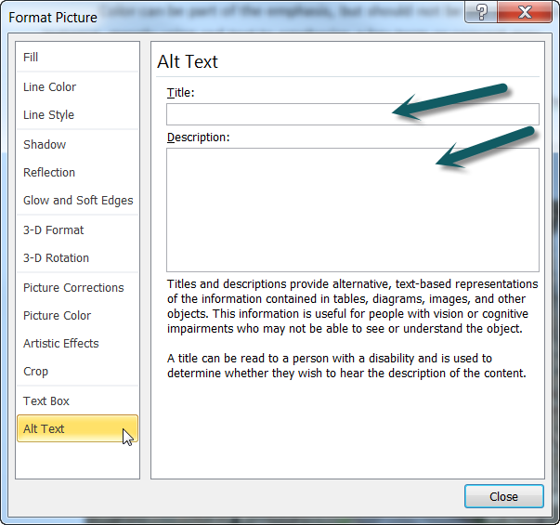

To Save as a PDF
- Go to “File” and select “Save As”

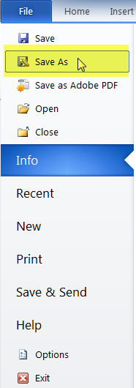

- Under the File name in the area labeled “Save as type” select PDF

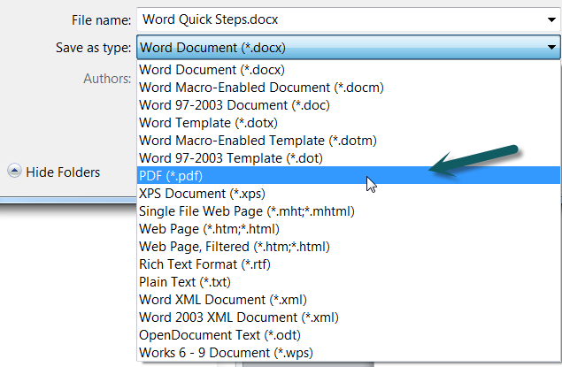

- Select “Options”

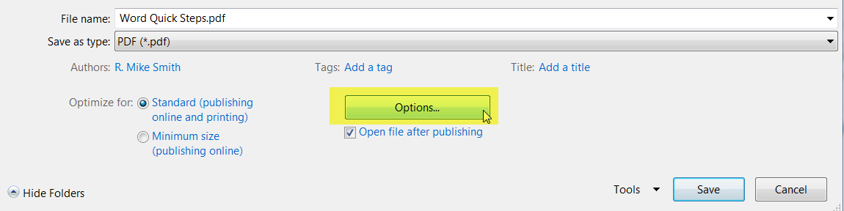

- Under the section labeled “Include non-printing information” ensure that “Create bookmarks using ‘Headings’” is selected as well as the check boxes titled “Document Properties” and “Document Structure tags for accessibility.” This will help screen readers identify the heading levels and read it correctly for end users.

