AdobeConnect Guide for CFEI Events
February 2017

Tip: Use Internet Explorer.

Session weblink: http://connect.tamuc.edu/cfei_session/

It is recommended to enter the AdobeConnect session at least 15 minutes beforehand. To troubleshoot any technical or access issues the day of the session, please call the CFEI at 903-886-5511. If encountering connectivity problems, call into the session using the following phone numbers: Conference Room is 903-468-8672, and Training Lab is 903-468-8770.

Speakers
Make sure the speakers are on by clicking the speaker icon and turning it green.
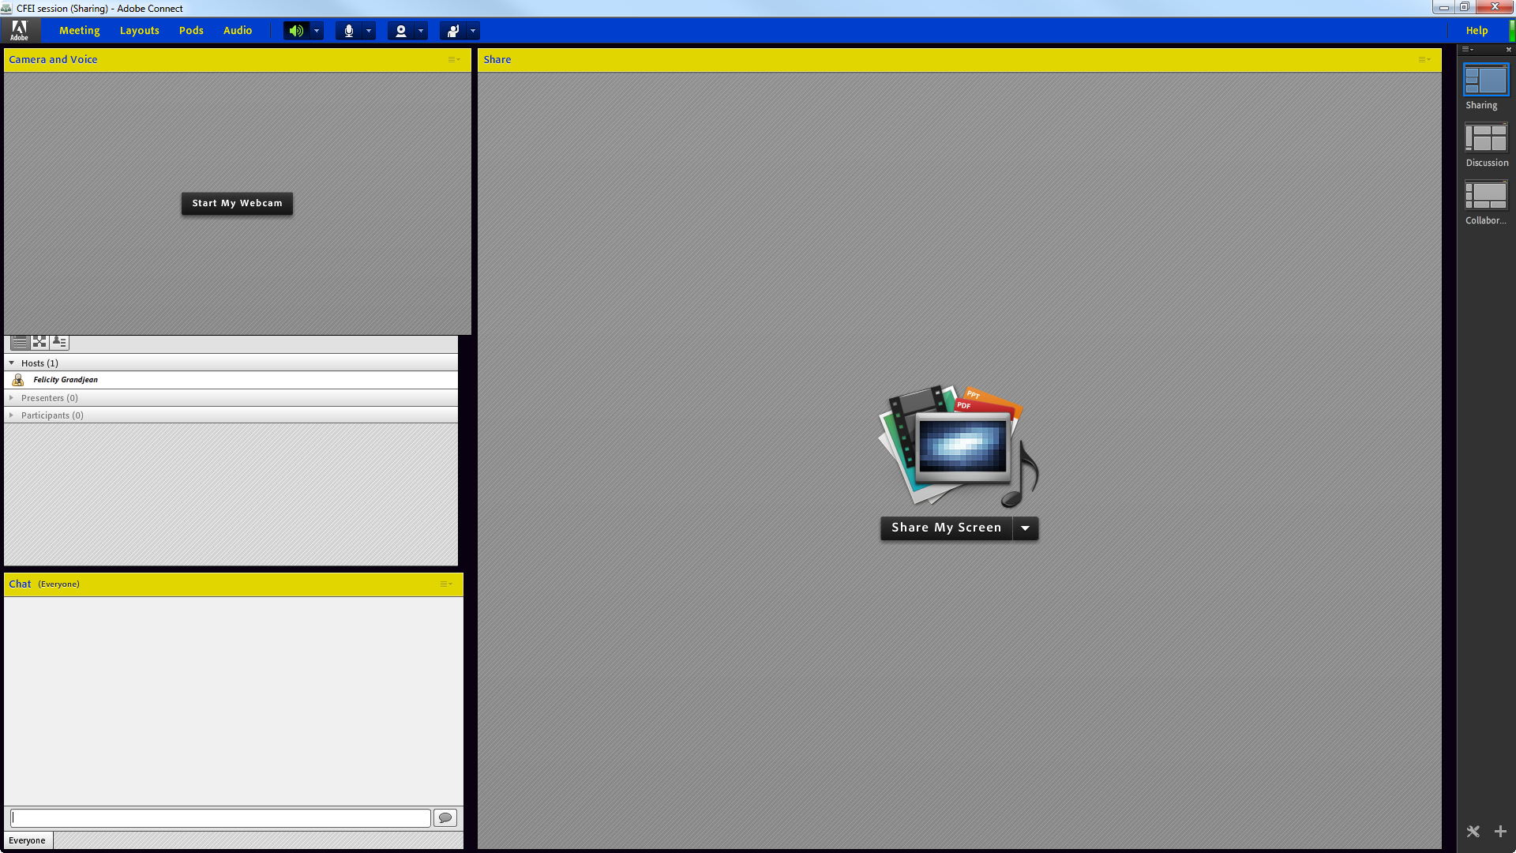

If the speakers are muted, use the drop down arrow to deselect “Mute Conference Audio.”
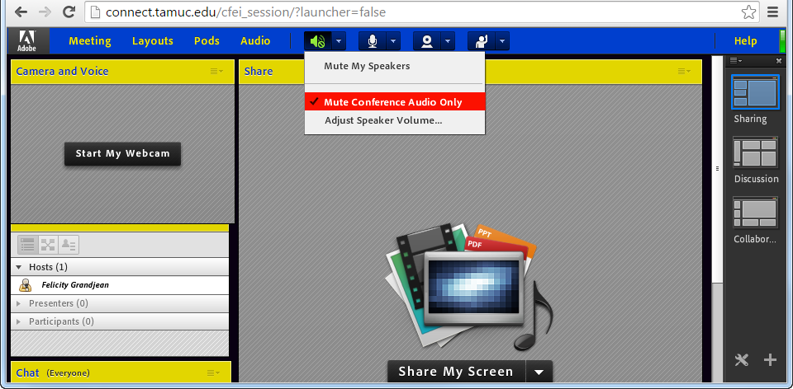

Microphone
Configure and turn on the mic by using the drop down arrow next to the icon (it will turn green when on and make sure it is not on mute).
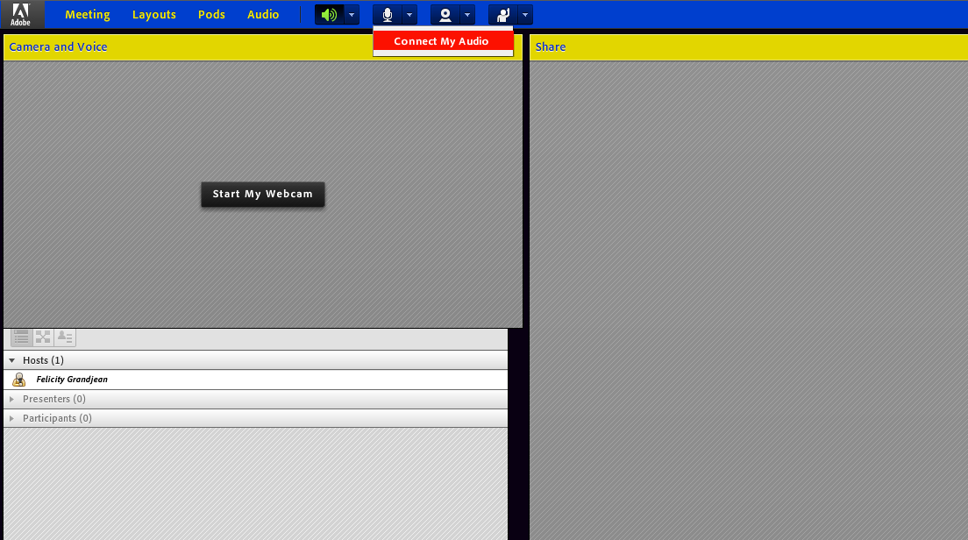

When asked to grant permission, select “Allow.”
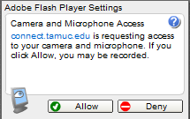

Webcamera
Configure and turn on the camera by using the drop down arrow next to the icon.
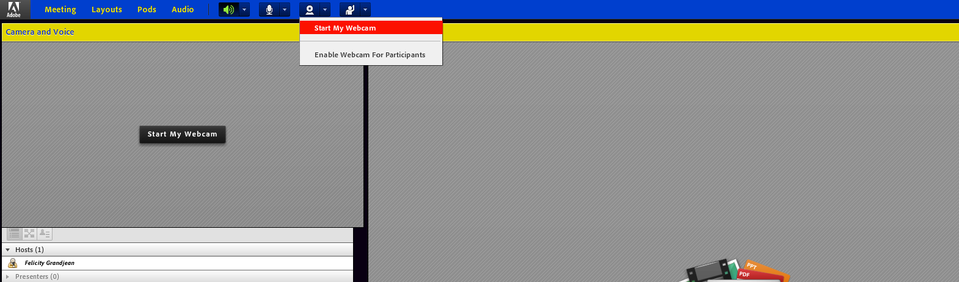

When everything is enabled, the toolbar looks like this.
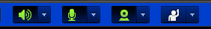

For more information on AdobeConnect, go to http://www.tamuc.edu/facultyStaffServices/centerForFacultyExcellenceAndInnovation/educationalTechnology/adobeConnect.aspx. To obtain an AdobeConnect account to create meetings, contact the CITE HelpDesk at helpdesk@tamuc.edu.

A recording of the session will be made available shortly after the session. You will find the link to the recording on the CFEI website.

