Add Coverage to Your New Dependent

Overview
This job aid outlines the process for an Employee to add or edit Dependents and add or remove those Dependents from benefits coverages in Workday
Prerequisites: N/A
Important Information:
  - Supporting documentation is required when a Dependent is added or information is updated
  - In case of a DIVORCE, you must change the relationship of your spouse to ex-spouse and any stepchildren to ex-stepchildren in order for them to be offered COBRA continuation coverage
  - The required information for this process is the Effective Date, Reason, Legal Name, Gender, Date of Birth, Relationship and Contact Information
  - You must enter life event changes within 60 days of the life event
  - You must add a Dependent or edit a Dependent’s personal information before starting a benefit change

Steps
To begin, you need to enter the person’s information into Workday and identify them as a Dependent

Add the Dependent to Your Profile
From the Workday Home page:
- Click the Benefits worklet
- Click the Dependents link
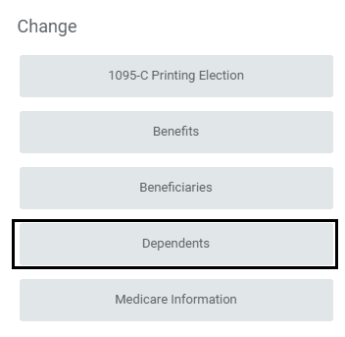
- On the Dependents page, perform one of the following actions:
- Click Add to add a new Dependent
- Click Edit to update existing Dependent
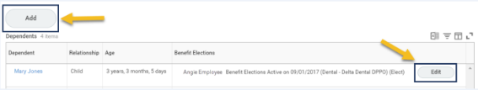
- In the Dependent Options section, add or edit the information including:
- Effective Date. Enter today’s date or the date this person can legally be identified as a Dependent for benefits purposes
- Reason. Enter the reason for adding the Dependent or making changes
Note: Click on the boxes or the Edit icon to add Dependent details
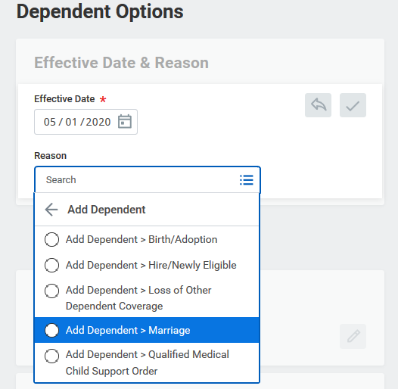
- In the Dependent Personal Information section, add the following information:
- Legal Name. Enter the Dependent’s full name
- Gender. Select one
- Date of Birth. Enter the birthdate
- Relationship. Select one
- Tobacco Usage. Select Yes or No
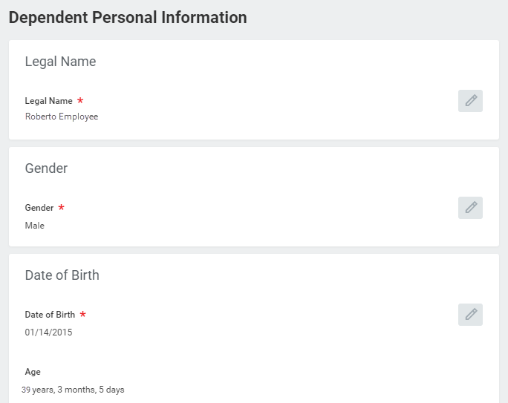
IMPORTANT: Only System Benefits Administration can update the Disability Status field. Contact your Benefits Office for assistance with this section
- Add the necessary Contact Information
- Add information in the Identifier Information section for the Dependent’s National ID
- Country
- National ID Type (SSN/ ITIN)
- Add/Edit ID Number
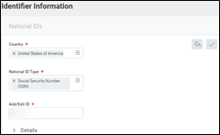
- Click Submit
You will receive a To Do in your inbox to upload supporting documentation to HRConnect

Upload Supporting Documentation
- Go to your Workday inbox
- Click the To Do: Upload Dependent Documentation
- On the Complete To Do Upload Documentation page, click the link to be directed to HRConnect
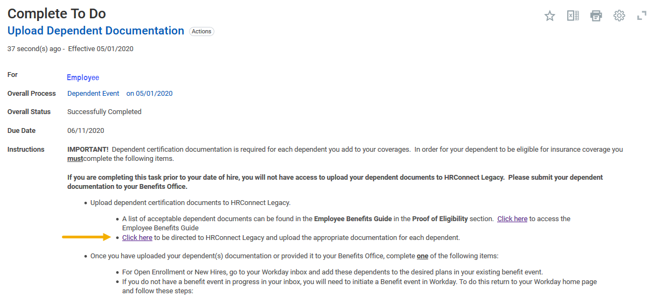
- Select the Document Category, Document Type and upload the supporting documentation for the Dependent by clicking the Choose File button
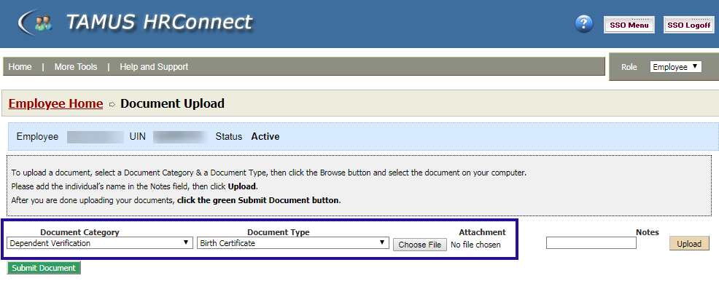
- Click Upload after attaching the document
- Click the Submit For Approval button after uploading the necessary documentation
- Once you have uploaded the document, you will see a message display that the documents were submitted successfully
- Return to your Workday inbox using the tabs at the top of your browser’s screen
- Click Submit at the bottom of the Upload Dependent Documentation To Do after you have uploaded your documents on HRConnect

Up Next
The Benefits Partner receives a To Do to review the Dependent documents

Add Coverage to Dependent
You are now ready to add the Dependent to coverage. This process involves two steps. First you will initiate a Benefit event, then you will make your changes to coverage for the Dependent
IMPORTANT: If your new Dependent is a grandchild, your Benefits Office must review and certify the Dependent before coverages can be added

Initiate Benefit Event in Workday
- From the Workday Home page, click the Benefits worklet
- Click the Benefits link
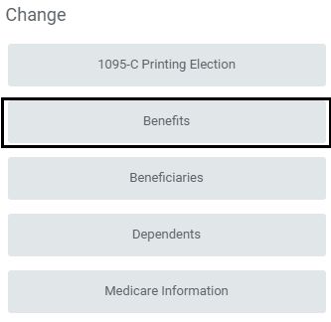
- Read all of the instructions at the top of the Change Benefits page before making a benefits change
- Complete the following fields:
- Benefit Event Type. Select a type
- Benefit Event Date. Enter the date of the event
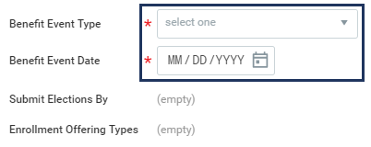
Note: The Submit Elections By and Enrollment Offering Types fields will auto-populate depending on the entries in the first two fields
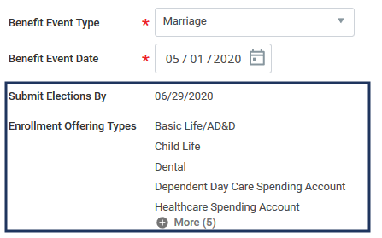
Note: Do not attach or upload any documents on this screen
- Click Submit
Next, you will receive an inbox task to Change Benefit Elections

Change Benefits Elections
- Navigate to your inbox
- Click the “Benefit Change” inbox action item
Note: The Change Benefit Elections task is a multi-step process

Select Health Care Elections
- Change your election if necessary, for the tobacco usage question
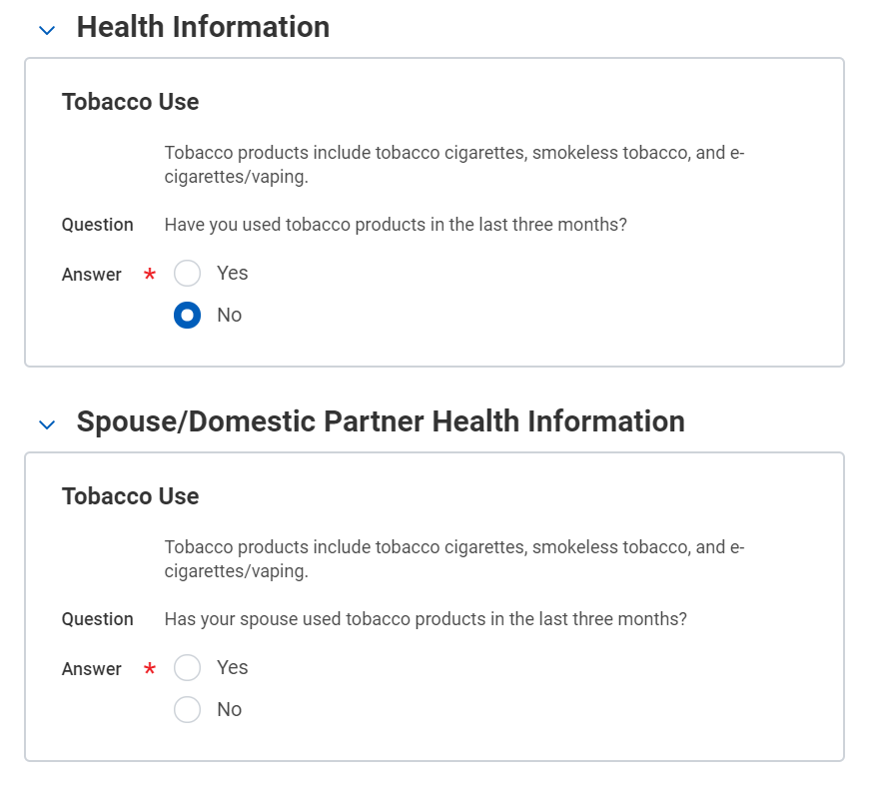
- In the Health Care Elections section, do the following:
  - Make changes to elections as needed. Any plans in which you are already enrolled will appear as elected, all other plans will be waived.
  - Add a Dependent to a plan by clicking the cell in the column Enroll Dependents. This will provide a prompt for you to make selections.
IMPORTANT: Only people you have formally added as a Dependent in Workday will appear as options
- Click Continue
- Enter a Social Security Number (SSN) for each Dependent
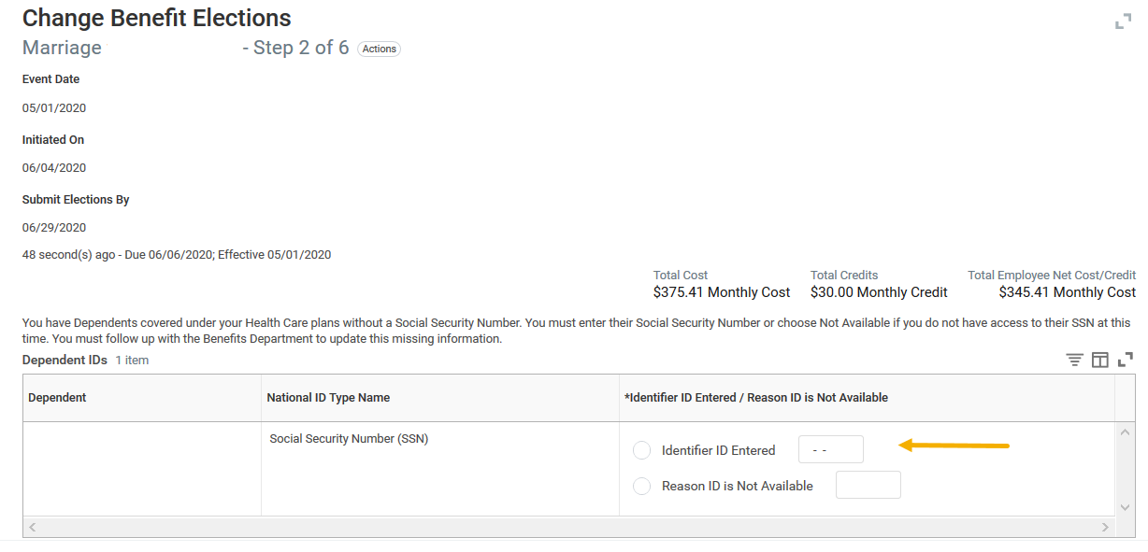
Note: If you have already provided an SSN for your Dependent, this screen will not display
- Click Continue

Spending Account Elections
- Select coverage for Healthcare or Dependent Day Care Spending Accounts
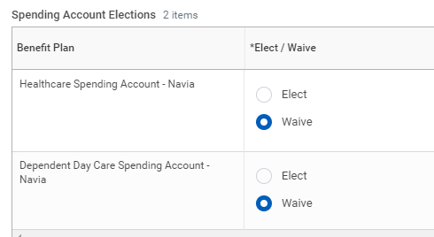
- If a Spending Account is elected, enter an amount for either a yearly contribution or per pay check. Workday will automatically calculate remaining fields
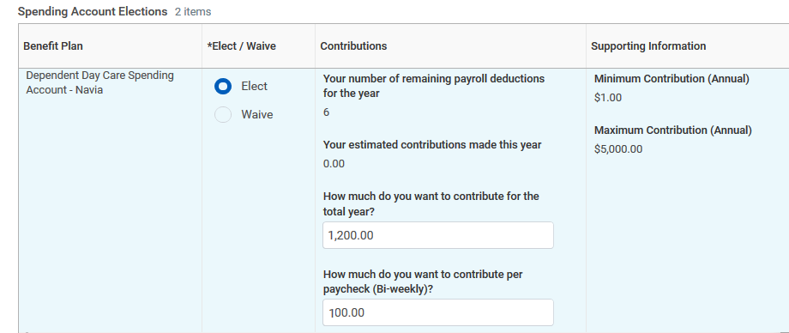
Note: Mid-year changes may result in discrepancies with the calculated bi-weekly premium. Contact your Benefits Partner if the amount does not calculate correctly
- Click Continue

Insurance Elections
- Select coverage for Dependents for the elected plan, as needed
- Click the prompt menu in the box for Dependents to get a list of Dependents that can be added
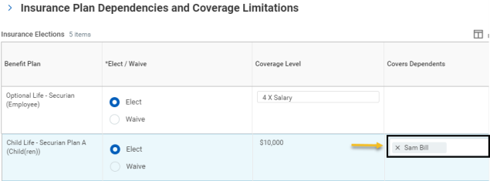
Note: Any plans in which you are already enrolled will appear as elected, all other plans will be waived
- Click Continue

Select Beneficiary Designations
In the Beneficiary Designations section, do the following, as needed:
- Add one or more Beneficiaries
- Select Primary or Contingent Percentage and enter the percentage using whole numbers
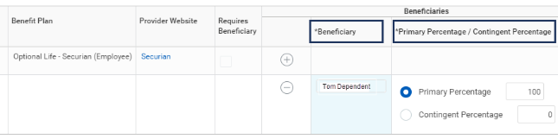
Note: You must elect one or more Primary Beneficiaries totaling 100%
- Click Continue

Review Benefit Elections
- Review all of the Benefit Elections made on the previous pages including elected or waived coverages, beneficiary designations, etc.
- In the Electronic Signature section, review the statements and click the I Agree checkbox
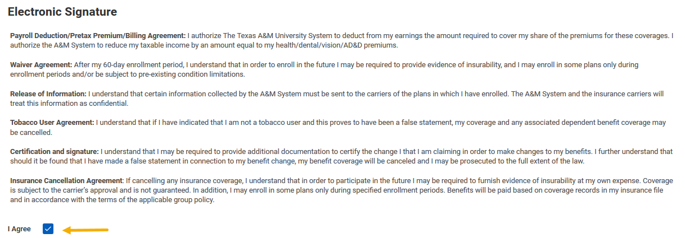
- Click Submit

Submit Elections Confirmation
- You can see the additional cost and view the change you have made
Note: You may print your coverages if desired. Click the Print button. The details will be saved in a PDF format from which you can print the document
- Click Done
This completes the Add Coverage to New Dependent process

