Complete Open Enrollment

Overview
This job aid outlines the activities for an Employee to complete or change Open Enrollment benefit elections during the Open Enrollment time period
Prerequisites: Open Enrollment has been launched for the Texas A&M University System
Important Information:
- The use of the term Employee can be interchanged with the term Retiree for this job aid
- Open Enrollment does not allow a Retiree to change Medical plans. If you are a Retiree who needs to add, drop, or change to/from A&M Care plan, the 65 PLUS plan or RAAMP plan as part of Open Enrollment, please contact your Benefits Partner so that an Alternate Open Enrollment can be initiated for you
- New Dependents must first be added in Workday as a Dependent, prior to adding them to any benefit elections
- Spending accounts are set up on a yearly basis. If you need to continue a spending account, you will need to re-elect the benefit and complete the Open Enrollment task each year to continue
- REMEMBER: You may be prompted to complete your Open Enrollment task again after completing it, if you experience a life event such as Birth or Marriage and initiate a Change Benefits for Life Event business with an effective date prior to September 1, or if your position changes (including scheduled hours, term months or pay frequency)

Review Current Benefit Elections
As a best practice, Employees should review their benefit elections in Workday prior to completing Open Enrollment
- Click the Benefits worklet on your Workday Home page and select Benefit Elections
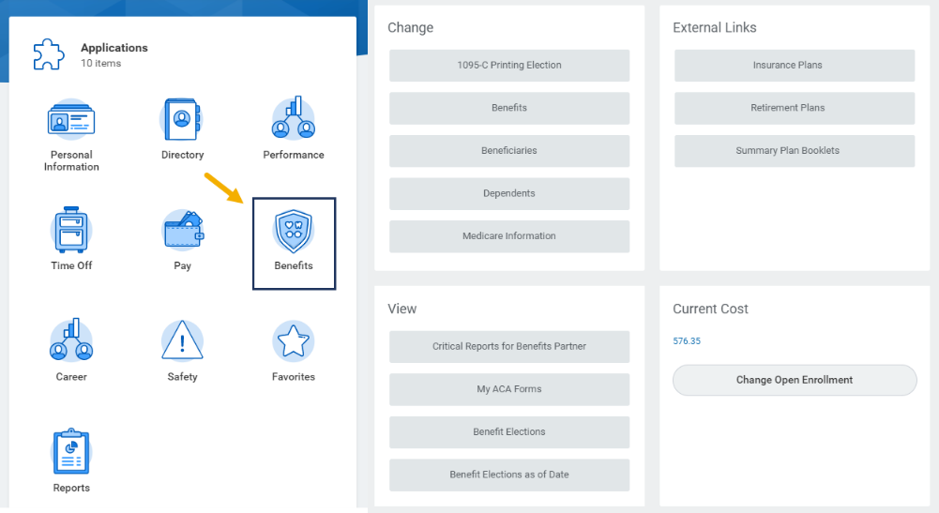
- Click OK
- Review your benefit elections and make note of any changes you may want to make
- Return to the Workday Home page and follow the instructions provided in the next section of this job aid

Review Dependents Listed in Workday (If applicable)
Prior to completing your Open Enrollment, you should review your Dependents in Workday to ensure that all Dependents who need coverage are listed. You will not be able to add coverage to anyone who does not exist as a Dependent in Workday
- Click on the Benefits worklet on your Workday Home page
- In the Change menu, click Dependents. View the Dependents already listed in Workday and determine if any should be added
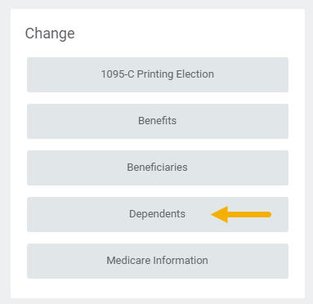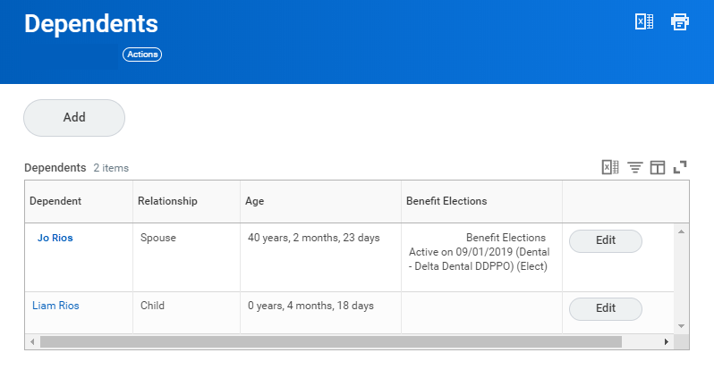
Note: You may have Dependents listed that you may not want / need to provide benefits coverage. When you are making your elections for Benefits, you will uncheck the box next to that person’s name if they need to be removed from coverage
- Add Dependents as needed. If you need to add a Dependent, click Add and complete the requested information
Note: You can refer to the Add Coverage to Your New Dependent job aid for detailed information on adding and editing Dependents

Up Next
You will receive a To Do in Workday that provides a link to HRConnect Legacy to upload required Dependent documentation
You are now ready to complete your Open Enrollment. The next section will guide you through this process

Complete Open Enrollment Change Task
This section will take you through the various steps to review and edit your benefit elections. You can complete your benefit elections in any order; however, within this job aid we will take you through the options sequentially. Some of the elections may not apply to you, so feel free to skip those if you want
IMPORTANT: Please be sure to read the instructions in Workday carefully. These instructions provide you with detailed information regarding your options and restrictions you need to know. This job aid will guide you through the process. However, it does not replace the detailed directions provided to you by System Benefits Administration.

Getting Started
Navigate to your Workday inbox and click the “Open Enrollment Change” task. You will then click the Let’s Get Started button
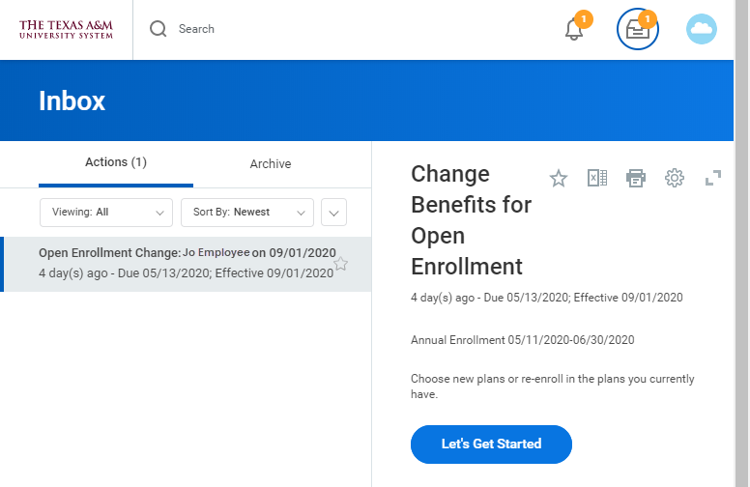
You will first need to complete the Health Questionnaire regarding tobacco usage. If you have a Spouse, you will complete the information for them as well. Then click Continue to move forward to your Annual Enrollment Summary page
IMPORTANT: Tobacco use includes vaping and e-cigarette use, as well as smokeless tobacco and cigarette use

Annual Enrollment Summary
From this page you can view the coverages available to you under the sections Health Care and Accounts and Insurance. You can review and edit any one of those elections, in any order.
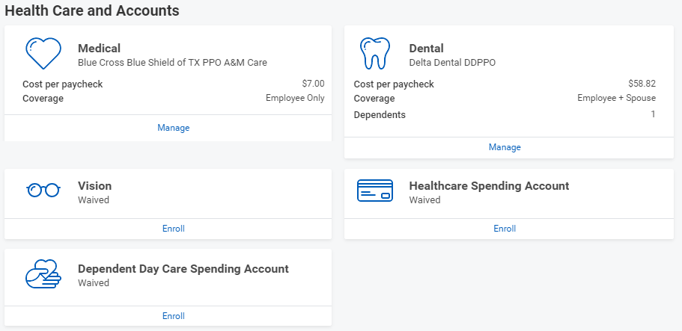
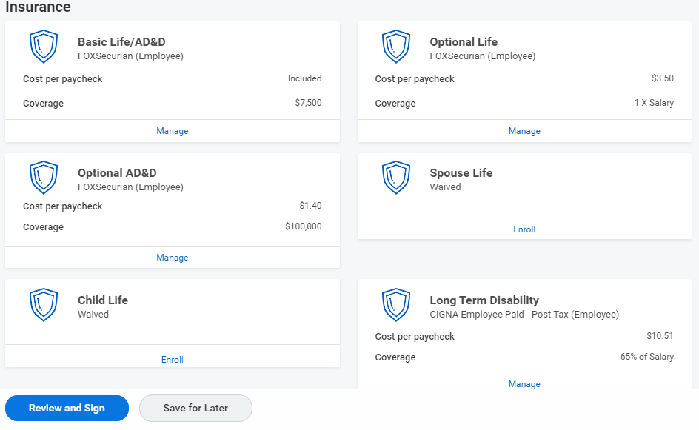
The Hartford (Employee)
The Hartford (Employee)
The Hartford (Employee)
REMEMBER: Spending accounts are set up on a yearly basis. You will need to re-elect this benefit each year
No changes to your benefits? If you are not making any changes to elections, you can click Review and Sign to view the summary of your elections, click the I Accept checkbox, then click Submit to complete the process

Healthcare and Accounts
You can navigate your benefit elections in any order. To begin each section you will click on Manage / Enroll. Those who have had previous coverage would see the Manage link. Others who are electing coverages for the first time will see the Enroll link. IMPORTANT: Be sure and read all instructions provided on the screen

Medical
- Click Manage / Enroll to begin
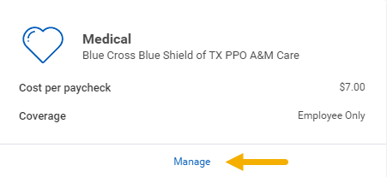
- You will see your available plans listed. Select or Waive as needed
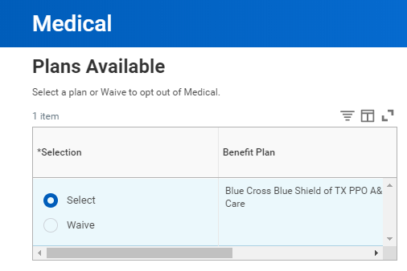
- Click Confirm and Continue
- Review your Dependents enrolled in this plan on the next page. Select or deselect Dependents as needed to enroll in or remove coverage
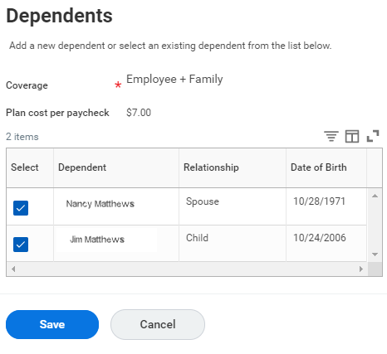
CAUTION!! If you have not yet set up your Dependents in Workday, you will not be able to add coverage for them. Click Cancel and return to your Workday Home page. Go back to the Review Dependents Listed in Workday section of this job aid for guidance. Do NOT continue until you have updated your Dependents in Workday
- Click Save to return to your Annual Enrollment Summary page

Dental
- Click Manage / Enroll to begin
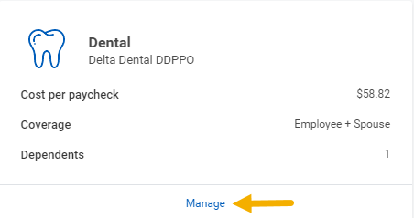
- You will see your available plans listed. Select or Waive as needed
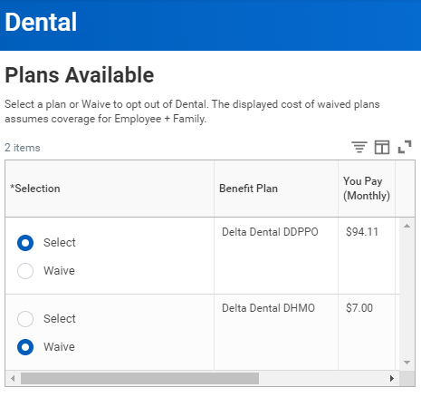
- Click Confirm and Continue
- Review your Dependents enrolled in this plan on the next page. Select or deselect Dependents as needed to enroll in or remove coverage
- Click Save to return to your Annual Enrollment Summary page

Vision
- Click Manage / Enroll to begin
- You will see your available plans listed. Select or Waive as needed
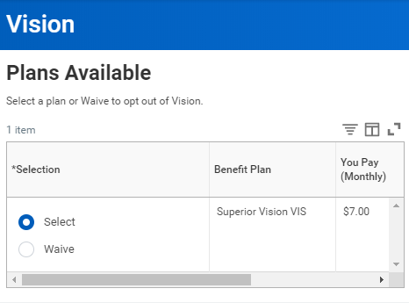
- Click Confirm and Continue
- Review your Dependents enrolled in this plan on the next page. Select or deselect Dependents as needed to enroll in or remove coverage
- Click Save to return to your Annual Enrollment Summary page

Healthcare Spending Account
- Click Manage / Enroll to begin
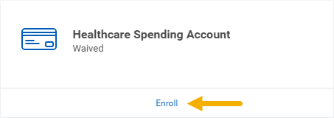
- You will see your available plans listed. Select or Waive as needed.
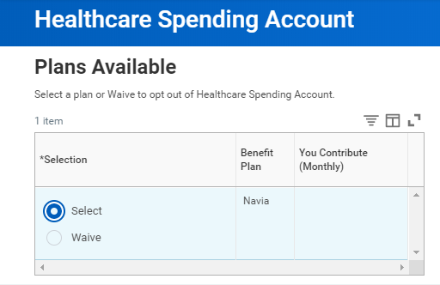
- Click Confirm and Continue
- Enter the sum you wish to contribute either per paycheck OR Annually. Verify that you enter that information in the appropriate field
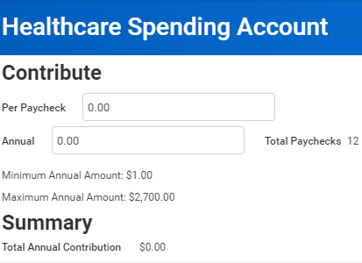
Note: It is recommended that you enter the sum annually so it automatically calculates per paycheck
- Click Save to return to your Annual Enrollment Summary page

Dependent Day Care Spending Account
- Click Manage / Enroll to begin
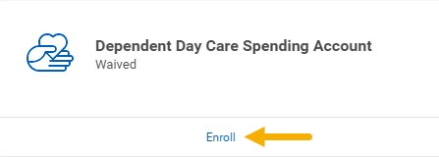
- You will see your available plans listed. Select or Waive as needed
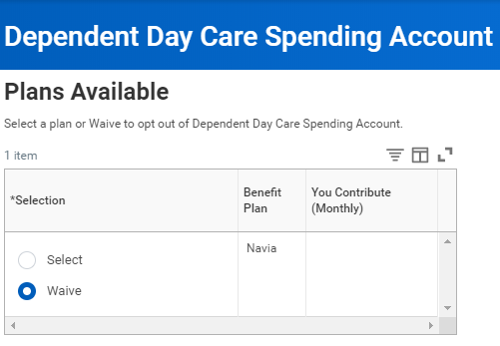
- Click Confirm and Continue
- Enter the sum you wish to contribute either per paycheck OR Annually. Verify that you enter that information in the appropriate field
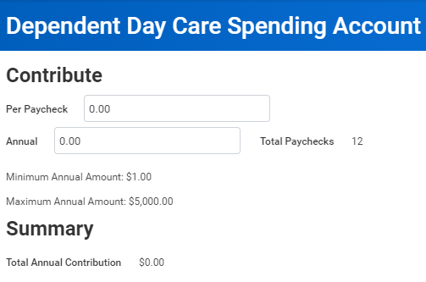
Note: It is recommended that you enter the sum annually so it automatically calculates per paycheck
- Click Save to return to your Annual Enrollment Summary page

Insurance
This section will guide you through electing your life insurance and long term disability plan elections
Note: As of September 2020, The Hartford is our life insurance vendor

Basic Life/AD&D
- Click Manage / Enroll to begin
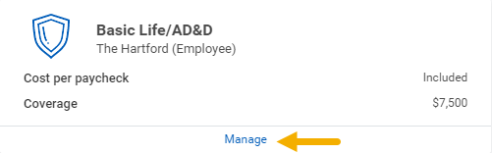
- You will see your available plans listed. Select or Waive as needed
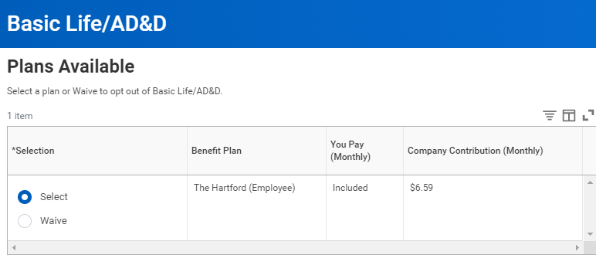
- Review / edit Beneficiaries for this plan
Note: If the Beneficiaries listed on the plan are correct, move to the next section of this job aid, otherwise follow the next steps for editing your Beneficiaries

Edit Beneficiaries
- Remove or add Beneficiaries as needed by clicking the plus or minus icons
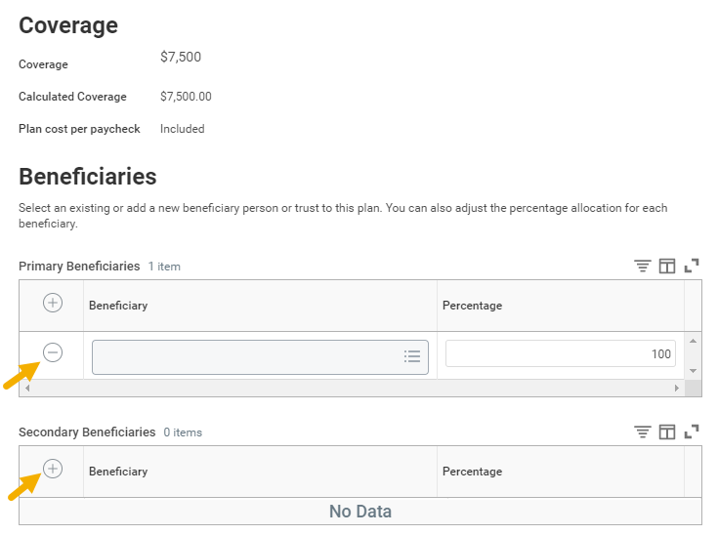
- To identify a Beneficiary, start by clicking the prompt icon
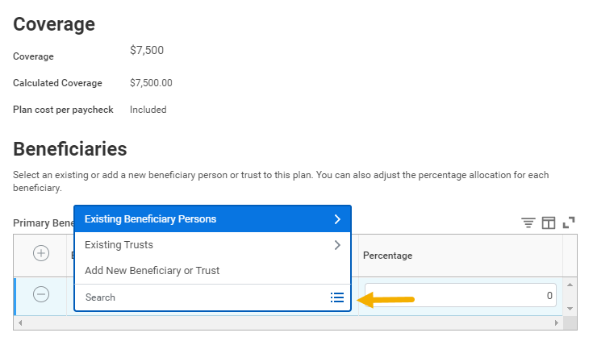
- Select Existing Beneficiary Persons if the Beneficiary is already listed in Workday. Choose the Beneficiary from the options listed
Or
- Select Add New Beneficiary or Trust to add a Beneficiary or Trust not yet listed in Workday. Indicate whether this will be a New Beneficiary or New Trust. Click Continue
- Fill out all required fields requested and Click OK
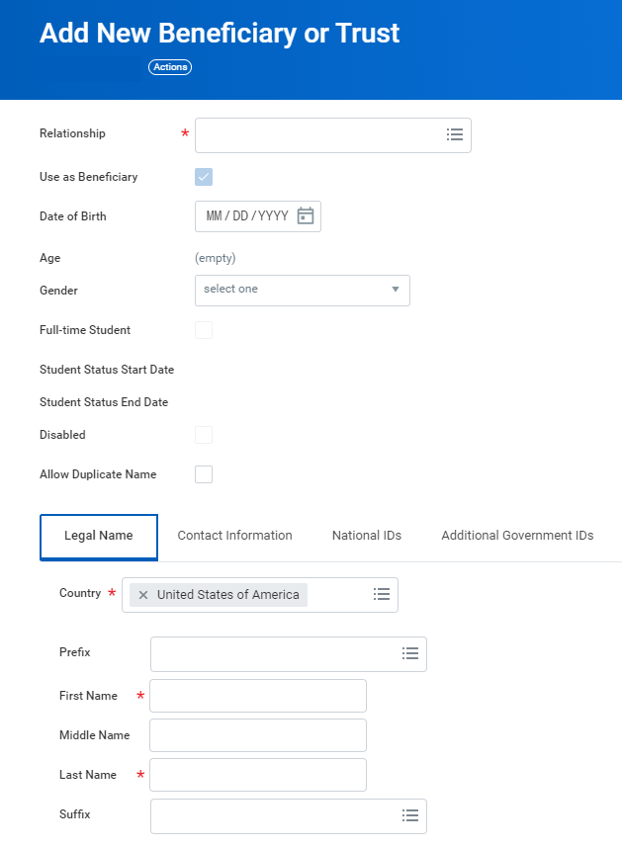
Be Advised: An address will be required to complete the process
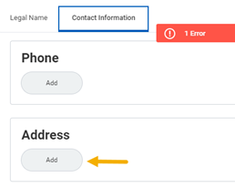
Notes:
- When adding multiple Beneficiaries to one policy, you will need to determine the percentage you would like distributed to each Beneficiary
- The combined distribution needs to total 100%
- Click Save when you are finished creating and / or editing Beneficiaries to return to the Annual Enrollment Summary page

Optional Life
- Click Manage / Enroll to begin
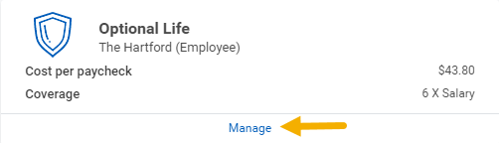
- You will see your available plans listed. Select or Waive as needed
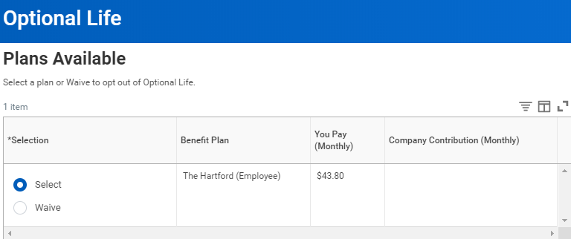
- Click Confirm and Continue
- Select desired options for coverage
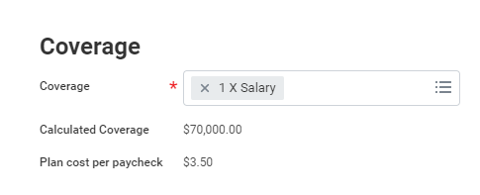
- Review your Beneficiaries. Follow the steps provided in the Edit Beneficiaries section on page 8, if necessary
- Click Save to return to the Annual Enrollment Summary page

Optional AD&D
- Click Manage / Enroll to begin
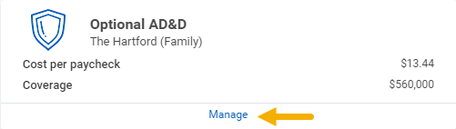
- You will see your available plans listed. Select or Waive as needed
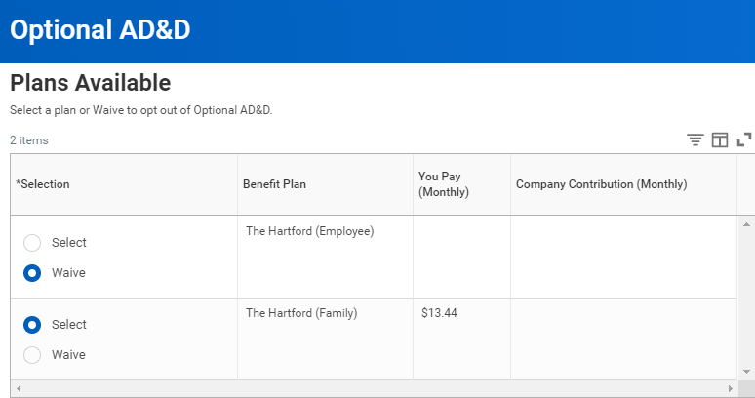
- Click Confirm and Continue
- Select the desired options for coverage
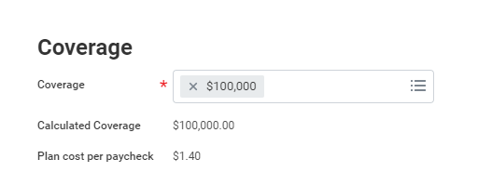
- Review your Beneficiaries. Follow the steps provided in the Edit Beneficiaries section on page 9, if necessary
- Click Save to return to the Annual Enrollment Summary page

Spouse Life
- Click Manage / Enroll to begin
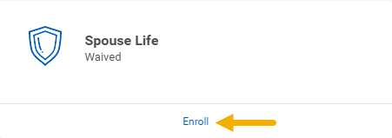
- You will see your available plans listed. Select or Waive as needed
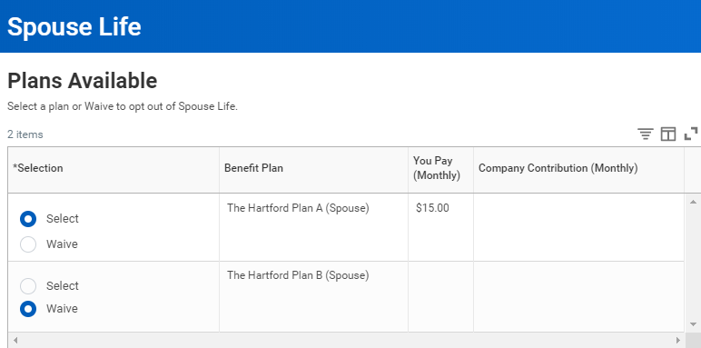
- Click Confirm and Continue
- Select your desired option for coverage
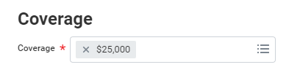
- Review your Dependent. Follow the steps provided in the Review Dependents Listed in Workday section on page 2, if necessary
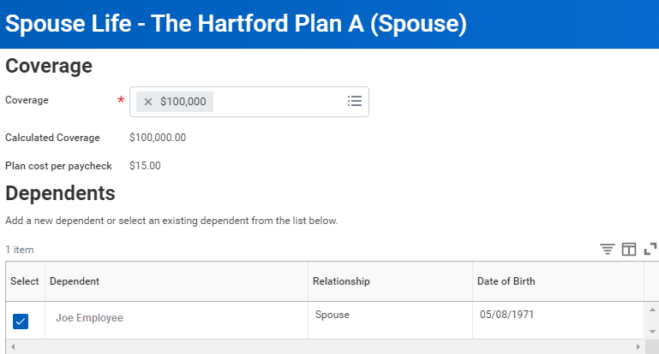
- Click Save to return to the Annual Enrollment Summary page

Child Life
- Click Manage / Enroll to begin
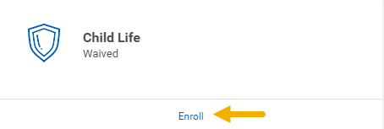
- You will see your available plans listed. Select or Waive as needed
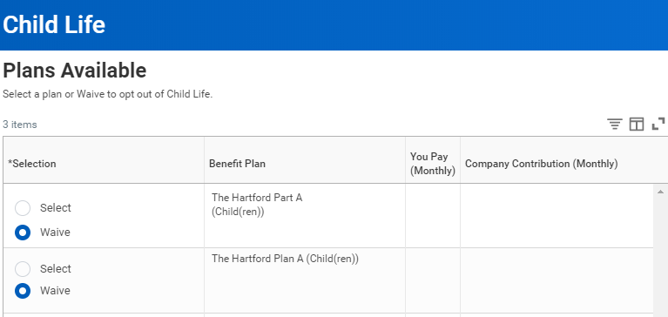
- Click Confirm and Continue
- Review your Dependents. Follow the steps provided in the Review Dependents Listed in Workday section on page 2, if necessary
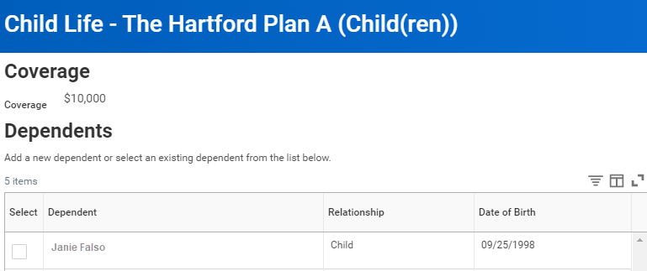
- Click Save to return to the Annual Enrollment Summary page

Long Term Disability
- Click Manage / Enroll to begin
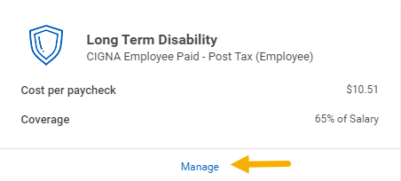
- You will see your available plans listed. Select or Waive as needed

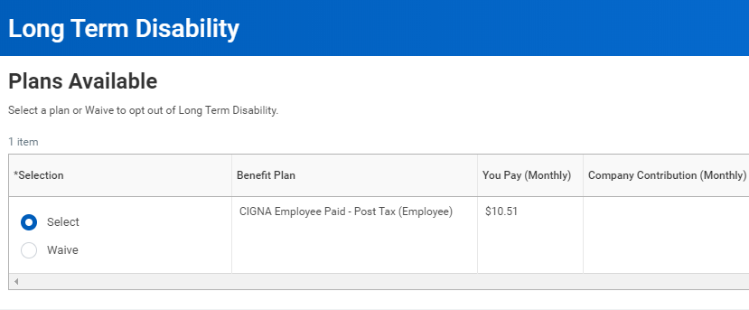
- Click Confirm and Continue
- Review your coverage details
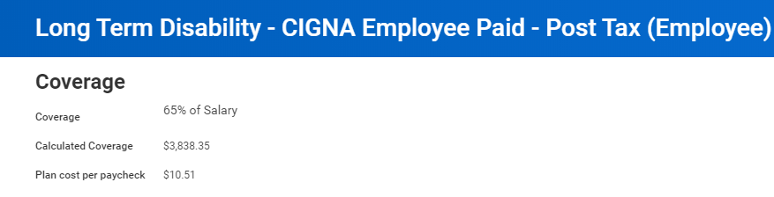
- Click Save to return to the Annual Enrollment Summary page

Finished Making Your Elections?
If you are finished making your elections, it is time to finalize your Open Enrollment
- Click Review and Sign on the Annual Enrollment Summary page and review your changes to confirm that they are correct
Note: If you need to make changes click on Cancel to return to the Annual Enrollment Summary page
- Check the I Accept checkbox
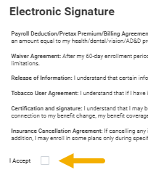
- Click Submit
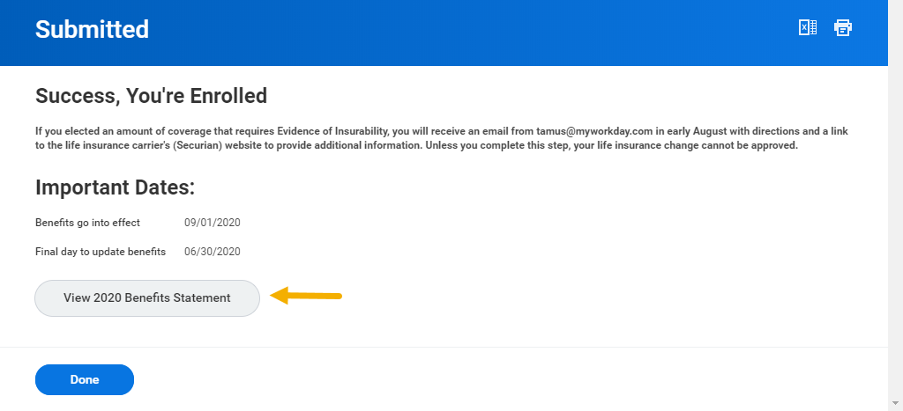
- From the Submitted page, you have the option to view your benefits statement by clicking the View 2020 Benefits Statement button
- Click Print if you would like to print the information or click Done
This completes the Open Enrollment Change business process

