Frequently Asked Questions
Assessment FAQs

Who participates in assessment at A&M-Commerce?
At A&M-Commerce, each educational program, both graduate and undergraduate, as well as the General Education Core Curriculum participates in Institutional Effectiveness (IE) through the assessment of student learning outcomes. Each divisional support unit, including academic and student support services such as Career Development, Student Advocacy and Support, and Student Health Services, as well as administrative support services such as Extended University locations, the Budget Office, and Emergency Management and Safety participate in IE through the assessment of goals. One designated faculty or staff member IE Author is charged with documenting the assessment plan and annual results for each academic program and support unit.

What is the difference between academic program assessment and support unit assessment?
Academic programs assess student learning outcomes, which represent what students are able to demonstrate in terms of knowledge, skills, and attitude upon completion of an educational program. Support units are classified in two types – either administrative support services or academic and student support services. Administrative support services provide operational support for the university. They assess quality of service targets such as efficiency, response rates, usage, and monetary targets. Academic and student support services provide services to support students and faculty. They assess expected outcomes such as quality of service targets and, in some cases, student learning outcomes.

What are the steps in the assessment process?
Assessment occurs in an active, ongoing, and integrated cycle. The cycle begins with identifying expected outcomes and appropriate measures by which to assess those outcomes. Next, methods of assessment are conducted to assess the achievement of the identified outcomes. Once data is collected, the results are analyzed and used to seek improvements. Finally, we repeat this cycle of assessment to measure again and determine if the implemented changes have had a positive impact on the achievement of the identified outcomes. This is known as “closing the loop.”

How do I come up with goals or student learning outcomes?
Goals and student learning outcomes should be chosen to reflect the mission of the unit or program. For helpful tips on writing goals and student learning outcomes, please see the resource guides – Writing Goals for Support Unit Assessment and Writing Student Learning Outcomes for Academic Program Assessment.

What assessment methods should we use?
Assessment methods should align with and directly measure the outcome you are trying to assess. Best practices recommend a combination of direct and indirect methods. For helpful tips on selecting assessment methods, please see the resource guides – Assessment Methods for Support Units and Assessment Methods for Academic Programs as well as our Definitions of Assessment Method Types.

Why can’t we use grades for assessment?
The program assessment conducted as a part of the university’s institutional effectiveness processes is intended to assess the performance of an academic program rather than the performance of individual students. Specifically, the program is inquiring to see if its identified student learning outcomes have been achieved by a cohort of students. To that end, assessment methods should precisely target those learning outcomes while grades often will incorporate other factors (format, adherence to directions, etc.) or learning components.

What is an annual assessment (IE) report?
An annual assessment (IE) report documents information about the program or unit’s assessment plan, including identified goals or student learning outcomes and their associated assessment methods, as well as the results of those assessments for a given IE cycle (year). It documents actions describing how those results will be used to seek improvements in student learning or operational processes. Assessment reports are submitted annually within the Nuventive Improvement Platform and approved by Department Heads/Direct Supervisors, IE Representatives, and Deans/VPs.

What should I report if results for my assessment methods are not collected until after the IE results submission due date?
In some cases, assessment results may only be available following a certain date such as the close of the fiscal year, the 20th class day, etc. In most cases it is not recommended to report partial data in your assessment results for IE but rather data from the most recently ended period prior to the results submission due date. For example, if your report includes fall enrollment data that is finalized as of October 2024 but the 23-24 results submission due date is in September 2024, you should plan to submit results for enrollment data finalized in the prior period – Fall 2023.

Where can I find my program/unit’s archived Assessment Plans and Reports?
Assessment reports beginning with 2018-19 Results and 2019-20 Plans are available within the Nuventive Improvement Platform to IE Authors or other IE participants with access. To receive copies of historical reports dated further back, please contact IE@tamuc.edu.

What resources and support are available to help me with assessment?
The Department of Institutional Effectiveness and Research offers many helpful resources to support you in your assessment efforts. Resource guides with information about assessment as well as manual and instructions for the use of the Nuventive Improvement Platform can be located on our website www.tamuc.edu/IE. Workshops and trainings are offered by IE staff throughout the year. Information about these offerings can be located on the IER Events webpage. For direct assistance with your assessment plan, please contact IE@tamuc.edu to request an individual meeting or a training session tailored to your department.

Nuventive FAQs

How do I get an account for Nuventive Improvement Platform?
Current participants in the Institutional Effectiveness process at A&M-Commerce will have access to a Nuventive Improvement Platform account, including IE Authors, Department Heads or Direct Supervisors, IE Representatives, and Deans/VPs or other final reviewers. If you believe you should have access or need to add a new user, please send an email to IE@tamuc.edu

What browser should I use to access the Nuventive Improvement Platform?
We recommend Chrome. Internet Explorer is not a supported web browser for the web application.

Who do I contact for assistance with using the Nuventive Improvement Platform?
Several helpful resources for using the Nuventive Improvement Platform are available on our website. Check out the User Manual, training videos, and other resources at www.tamuc.edu/IE. For direct assistance with using the platform, please contact IE@tamuc.edu.

Do I need to complete any training before I can access my Nuventive account?
To be granted full user access, you must complete the required training Utilizing the Nuventive Improvement Platform for Annual Assessment Reporting. This course is available on demand through TrainTraq by searching for course number 2114162. This training is also offered periodically in a live format. Check the IER Events webpage or the DevelopU calendar for information about upcoming offerings.

How can I get access to all of the Plans for which I am responsible?
The Plans to which you have access will appear in the drop-down list located at the top of the screen in Nuventive. If you are assigned to multiple Plans, click the down arrow to navigate between multiple Plans. Alternatively, you can begin typing the name of your program or division in the drop down menu and it will appear underneath. If a Plan to which you should have access does not appear, please contact IE@tamuc.edu to request access.

Is there a button to submit my annual assessment (IE) report?
There is no separate submit button. Those who need to access your report for review will be able to do so within the Nuventive Improvement Platform following the IE Author submission due date.

Do I need to submit a separate assessment (IE) Plan?
You do not need to submit a separate plan. Any Goals/SLOs which will carry over for assessment in the upcoming cycle should be marked for the upcoming Planned Assessment Cycle. This can be done within the menu option for Assessment Plan, when editing an SLO/Goal. 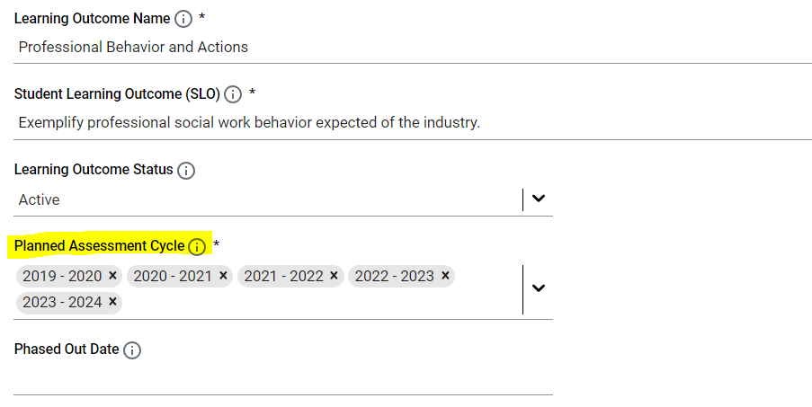

Or, if you choose to edit any existing SLOs/Goals and assessment methods or add any new, please do so by the IE Author submission due date. Please do NOT delete any SLOs/Goals or assessment methods.

How can I tell if my annual assessment (IE) report has been approved?
A report reviewer, such as a Department Head or IE Representative, who requests revisions before approving a report will notify the IE Author of this request. To view your approval status and feedback provided by reviewers within the Nuventive Improvement Platform, navigate to the Plan Review/Approval area and select the level of review you wish to view. When viewing the Review/Approval form, note whether an Initial or Final Review Decision has been marked. Approved reports will be marked “Approved” while reports not yet approved will be marked “Revisions Requested.”

If I am changing my SLO/Goal, should I edit the existing or create a new SLO/Goal?
We recommend that you edit an existing SLO/Goal if the following applies:
- The change is primarily grammatical in nature, with an emphasis on wording rather than meaning/substance.
- Your assessment method and results will still align with the edited SLO/Goal and can still be used as a measurement of the SLO/Goal.
- Note, any edits you make to an existing SLO/Goal will immediately reflect in your assessment report and will be associated with both past and future results entries. To preserve past details about the SLO/Goal, please describe these changes in the space for Notes in Assessment Methods.
We recommend that you create a new SLO/Goal if the following applies:
- The change is primarily substantive in nature, rather than to just the wording or grammar of the SLO/Goal.
- You intended to assess something different than what you have assessed before.
- Your existing assessment method(s) will not be used for the SLO/Goal.
- Note, if you create a new SLO/Goal, please do not delete the old SLO/Goal no longer included in your assessment plan. Instead, after the close of the IE cycle, mark the SLO/Goal as Phased Out from within the Assessment Plan area. Marking the SLO/Goal as phased out before the close of the IE cycle will remove it, along with any final results collected, from your annual (IE) assessment report. Once marked phased out, the SLO/Goal and any associated methods and results entries can be hidden if filtered out when navigating within your Plan and Results.
  - When running a two column report for historical results, you may wish to set the filter to select inclusion of all phased out SLOs/Goals.

If I am changing an assessment method for an SLO/Goal, should I edit the existing or create a new assessment method?
We recommend that you edit an existing assessment method if the following applies:
- What you are changing primarily relates to the administration of the method rather than what/how it measures.
- The assessment method type is not changing.
  - For example, if your program or unit is using a survey to assess a SLO or Goal but there are some minor changes to the question items on the survey, you could make a simple edit to the assessment method.
- Results for the revised method of assessment can still be meaningfully compared with past results.
- The assessment method remains the same but the standard of success is changing.
- Note, any edits you make to an existing assessment method will immediately reflect in your assessment report and will be associated with both past and future results entries. To preserve past details about the assessment method or prior standard of success, please describe these changes in the space for Notes.

We recommend that you create a new assessment method if the following applies:
- What you are changing primarily relates to what is being measured and how it is being measured, rather than to the administration of the method.
- The assessment method type is changing.
  - For example, if your program or unit has been using a survey to assess an SLO/Goal but has decided to use a student evaluation instead, this would be considered a more substantive change and would warrant creating a new assessment method.
- Results for the revised method could not be meaningfully compared with past results.
- Note, if you create a new assessment method, please do not delete the old assessment method no longer included in your assessment plan. Instead, after the close of the IE cycle, mark the Assessment Method as inactive from within the Assessment Plan area. Marking the method as inactive before the close of the IE cycle will remove it, along with any final results collected, from your annual (IE) assessment report. Once marked inactive, the assessment method and any associated results entries can be hidden if filtered out when navigating within your Plan and Results.
  - You may use the Notes section at the bottom of the Assessment Method editing screen to record what the previous assessment method was, why it was changed, and any impact the change will have on the methods, assessments, and SLO/Goal.
  - When running a two column report for historical results, you may set the filter to include all inactive methods.

